OFFER LETTER

Date: September 26, 2022

To,

Prashant B. Ratnaparkhi

It was a pleasure interacting with you over the last few days. Each member of our executive team was impressed with your candidature.

We refer to our discussions with you and are pleased to offer you an appointment with us as IT RECRUITER.

The terms and conditions and other details are given below.

Your place of Posting would be **Kolkata** and the date of joining would be **October 03, 2022.**

Compensation Details

You will be paid a fixed annual total compensation of Rs. 2,34,000/- (refer annexure ‘A’ for break up). Your targets will be defined, discussed and documented within a few days of your joining the company.

Benefits Details

In addition to the above-mentioned fixed pay package depending on your work profile, you will be entitled to a lucrative incentive payout. The structure for the same will be discussed with you on your date of joining. As per our incentive and bonus pay norms, you shall be on rolls of the company and shall not be serving notice period.

Your compensation is highly confidential and if the need arises, you may discuss it only with your Manager.

Annual Increment

We will follow an anniversary appraisal format and the review cycle runs from September. Consequently, you will be eligible for an annual increment based on your performance review.

Public Holidays and Working Hours

The working day shall comprise eight working hours and a lunch break for an hour. The normal working hours are between IST Time Zones.

You are entitled to have 10 holidays for the calendar year, details of the same will be shared post joining.

Amendments

All the above terms are as per our current policies and practices and may be amended from time to time. You will be informed of changes in the terms and conditions of service, if any. We look forward to you joining us and to a mutually rewarding association. Please do not hesitate to call us for any information you may need.

Separation from the company

At the time of formally resigning from service you shall need to serve the 15 days “Notice Period”. For any reasons if you fail in serving the notice the company has a right to hold your experience & relieving letter and salary.

If your services are terminated by the Company due to misdemeanour, unsatisfactory performance or any other disciplinary matter, the Company reserves the right to terminate your services without pay and notice.

Full & Final Settlement

In case of employees who have resigned from Ascloud Secure, their Full & final settlement would be made after 30 days from their last working day with Ascloud Secure upon the receipt of all tax-related documents.

Annexure A

Terms & Conditions of Employment

You shall be governed by the following terms and conditions of service during your employment with Ascloud Secure (hereafter referred to as the "Company"), and those that may be amended from time to time.

1. The organization conducts screening and background verification for its prospective hires. Your appointment and continuation of your services is subject to a clear and clean background report.
2. Your shift timings are subject to change as per the requirement of the business.
3. Your employment is subject to your undertaking that,

* You will clear the training and on the job evaluations that are pre-requisite.
* You will not directly or indirectly engage in any other work or assignment or talk up part/full time training.
* program without prior permission in writing of the Company. You will not divulge, disclose or leak out any information regarding the affairs of the Company, which comes to your knowledge, including the designs, patent process or trade of the Company or those of Company's collate rations [whether in India or abroad]
* You wilt also execute a service and confidentiality documents as applicable to employees from time to time.

1. Your services are able to be transferred to any of the branches of the Company or to any of its Group/Associate Company. The terms and conditions of this appointment will be binding on such transfers and your services will be treated as continuous services. Any subsequent change in rules, policies and regulations during the terin of your services of the company shall be binding upon you in totality.
2. During the period of your service if you are found medically unfit for work, the management shall have the right to require you to get yourself examined by any medical authority specified by the Company and management as its sole discretion may terminate your services based on such medical reports.
3. Your performance will be evaluated at regular intervals for salary review or salary increments, Increment shall be traded on your performance and in no case shall be automatic and/or can be claimed as a matter of right and shall be solely at the discretion of the Company.
4. Your services can be terminated without assigning any reasons as under:

a) At any time without any prior notice during the period of probation

b) With prior notice of minimum [1] One month or salary in lieu thereof, after confirmation.

1. Your services can, however, be terminated, without any notice or compensation and without assigning any reason for loss of confidence, or for any act including dishonesty, disobedience, negligence, fraud, misappropriation of Company's money, property or any subversive act which is seriously detrimental to the interest of the company and warrants your termination forthwith.
2. You will have to give minimum [1] one month prior notice if you want to resign from the services of the Company at any time. If you fail to give [1] one month prior notice, you will have to pay to the Company [1] one month's salary in lieu thereof. Notice period waive off or Notice period buyout option will be subject to company's sole discretion and binding on you.
3. An absence from duty for a continuous period of 2 days during probation and 7 days after confirmation, including absence on leave though applied but not granted, would make you lose your lien on the services and the same will automatically come to an end without notice or even intimation. The Company shall have full authority to initiate absconding and recovery proceedings against you.
4. You will retire from the services of the Company on attaining 60 years of age and for this purpose the official record of your date of birth with the Company will be treated as final.
5. During the period of the service in the Company, you shall

* Perform, observe and conform to such orders and instructions as may from time to time be reasonably given or communicated to you by the Supervisor,
* in all respects carry out the objects of the Company diligently and faithfully serve the Company, promote and protect its interest in all things to the best of your ability and judgment, and use your best endeavours to increase its business, and
* Devote your whole time and attention to the business of the Company during the office hours of the Company and shall not in any way be engaged in, concerned directly or indirectly with any other Company: Business or trade without the prior written consent of the Company
* Agree to enter into a service contract with the Employer which will require the Employee to remain with the organization for a defined period post his/her return to India. This service contract will be liable the event that he/she is required to travel abroad to a client site for business need.

1. The postal address shared by you shall be treated as the correct address for all communications to you. You undertake to promptly intimate the company in case of any change in the postal address. All communication addressed to you on the address shall be deemed to have been correctly served.
2. By accepting this letter of appointment, you acknowledge and agree that you will not, during the course of your service or thereafter, except with our consent, as required by law or in the performance of your duties, use or disclose confidential information relating to our business, including but not limited to business, client/s information, business methods and practices, software technology and tools and/or any such information we may assign time to time as being confidential.

I accept the above-mentioned terms and conditions of employment with the company

For Ascloud Secure Receivers Signature

(Authorized Signatory) Signature:

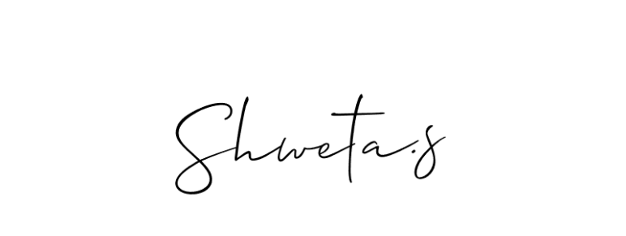

Full Name:

Shweta S.

Manager HR